
HOW A BILL BECOMES A LAW

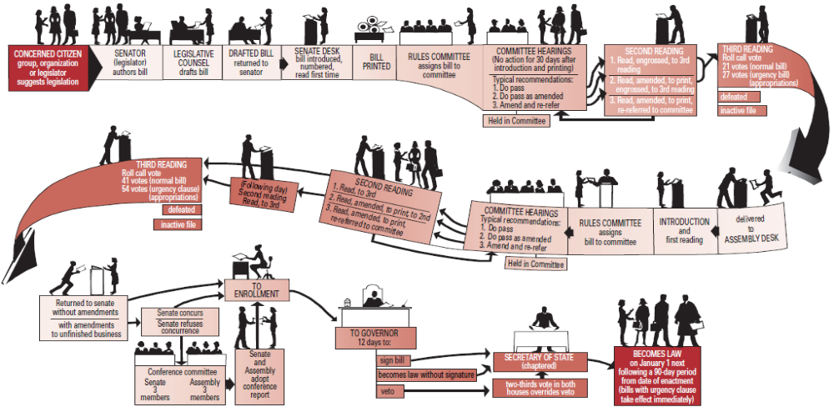

Compliments
of the
California
Senate

NOTE: This chart depicts the flow of a bill originating in the Senate; except for minor differences, the process is similar for bills originating in the Assembly.

